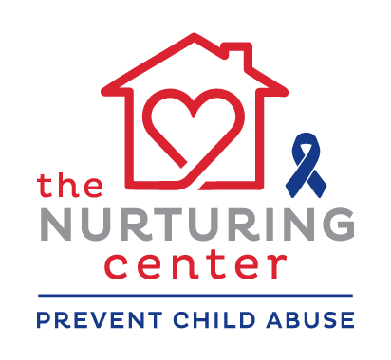

**COME STAND WITH US TO PREVENT CHILD ABUSE**

**Thursday, April 21st - 4:00-6:00 pm - Lawrence Park**

***(rain or shine)***

**On Thursday, April 21st, 4- 6pm,** The Nurturing Center will be hosting the annual Blue Ribbon Child Abuse Prevention Celebration at **Lawrence Park.** We hope your organization will **wear blue** and join us in creating a community event with food, music and family fun, while standing together against child abuse. There will be FREE FOOD and EVERYONE in our community is invited. We’ll once again be making our Human Blue Ribbon to demonstrate our commitment to the prevention of child abuse.

**We encourage your group to bring a children’s activity.** Coloring sheets, games, giveaways, mascots, & balloons are just a few ideas. Be creative! Let’s make this a fun, colorful, extravaganza for families. The Nurturing Center has limited tables to provide to the agency participants, so we are asking that you provide your own.

**Please complete the registration form below and return**

**to The Nurturing Center by Friday, April 8th.**

**-----------------------------------------------------------------------------------------**

Name of Agency/ Service ______________________________________________________________________________

Contact person _____________________________________________________________________________________

Address ____________________________________________City / State /zip __________________________________

Phone _______________________________________ Email _________________________________________

Do you have a Facebook Page? Name: ___________________________________________________________________

Bringing your own tent: Yes ______ No ______

Size of space needed: Sm 6 x 6 _____ Med 10 x 10 ______ Lg 12 x 12 _______ Other __________________________

Short description of your activity for location and space needs:

___________________________________________________________________________________________________________

___________________________________________________________________________________________________________

**\*If providing your own tent, the stakes must NOT be metal and cannot be longer than 6 inches ☺**

**Please return registration to:**

[jens@nurturingcenter.org](mailto:jens@nurturingcenter.org) or [kelsey@nurturingcenter.org](mailto:kelsey@nurturingcenter.org)

The Nurturing Center - 322 2nd Ave W Suite C - FAX756-1410

The Nurturing Center provides supportive, respectful services that strengthen families, increasing the number of children raised in healthy, nurturing environments.  More information about us can be found at [www.nurturingcenter.org](http://www.nurturingcenter.org) or on our Facebook page.